# CS 340 README

Author: Dominic Drury

Last Updated: 12/07/2023

## About the Project/Project Title

*This project is about developing an application that can take data from animal shelters and extrapolate that data to find suitable rescue animals.*

## Motivation

*Grazioso Salvare identifies dogs that are suitable to be trained as search-and-rescue animals. With this application, they will be able to use existing data from shelters to identify and categorize available dogs. This will both help reduce the animal population in shelters and increase the population of search-and-rescue animals.*

## Getting Started

*To get a local copy up and running, follow these simple example steps.*

1. *Make sure to have MongoDB installed on your device*
2. *Create a Mongo database with a meaningful but simple name (example: Austin Animal Control = database AAC*
3. *Create a user with read/write permissions*
4. *Import the data from the database*
   * *Make sure you are in the correct directory and that all the variables are properly inputted*
   * 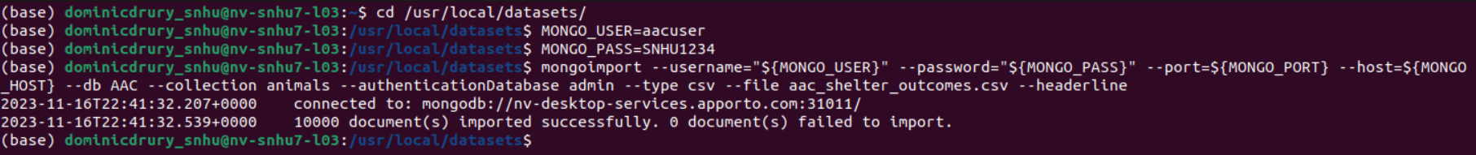
5. *Launch mongosh and use the database*
   * 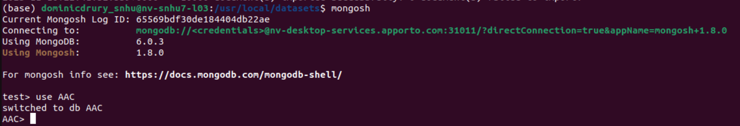
6. *In the AnimalShelter python file, update the _init_ function with the correct MongoClient, the database being used, and when launching make sure the username and password match the account you created*
   * 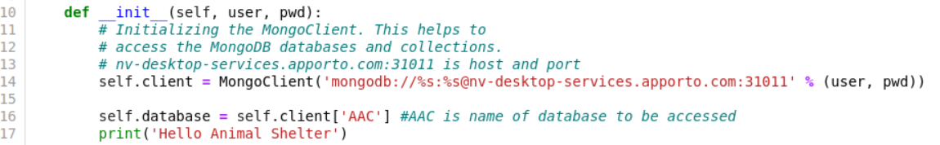

*To use the Create Function:*

*Add the data you wish to enter as a dictionary, then call the function as shown below. If the creation is successful there will be a “record added” printed to the screen*

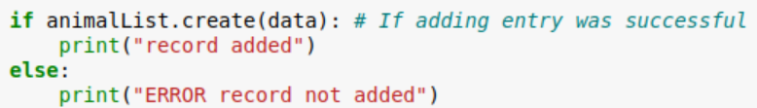

*To use the Read Function*

*Call the read function with a dictionary of the search term you are looking for as shown below. The results will be printed to the screen:*



*To use the Update Function*

*Call the update function with a dictionary search term and a dictionary update of information as shown below. The number of changes will be printed to the screen:*



*To use the Delete function*

*Call the delete function with a dictionary search term that will point to the entries you wish to be deleted. The number of deletions will be printed to the screen:*



## Installation

*You will need both the current version of MongoDB, Python, and the Jupyter Notebook*

*MongoDB was used as the model component for its versatility and ease of use. You can easily learn how to use it and there is plenty of wonderful tutorials on how to take advantage of its functionality. The Dash framework provides a separation between the high level of the application that the user sees and the lower levels. This separation allows for an easy to use and pleasant to look at application for the user and an easy to maintain lower level for the developer.*

## Usage

### Code Example

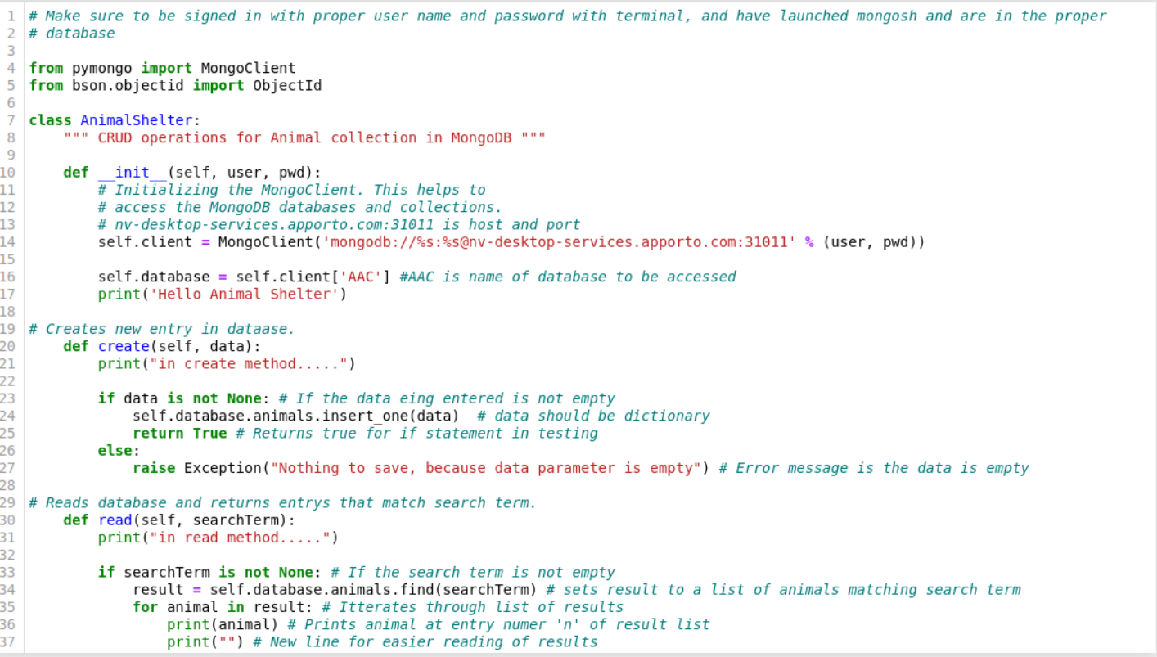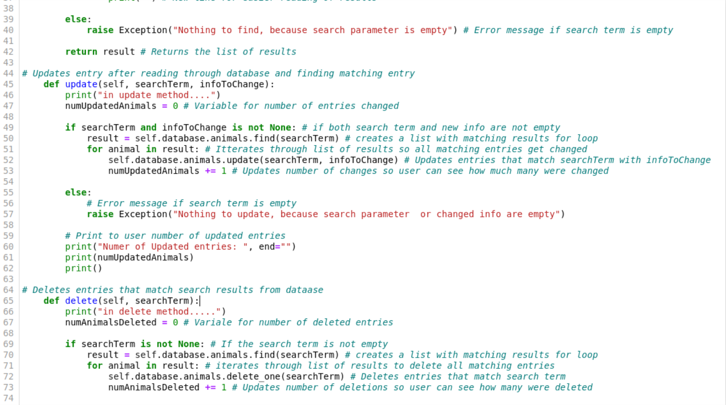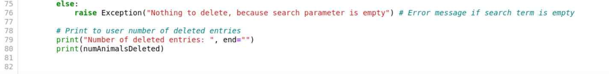

### Tests

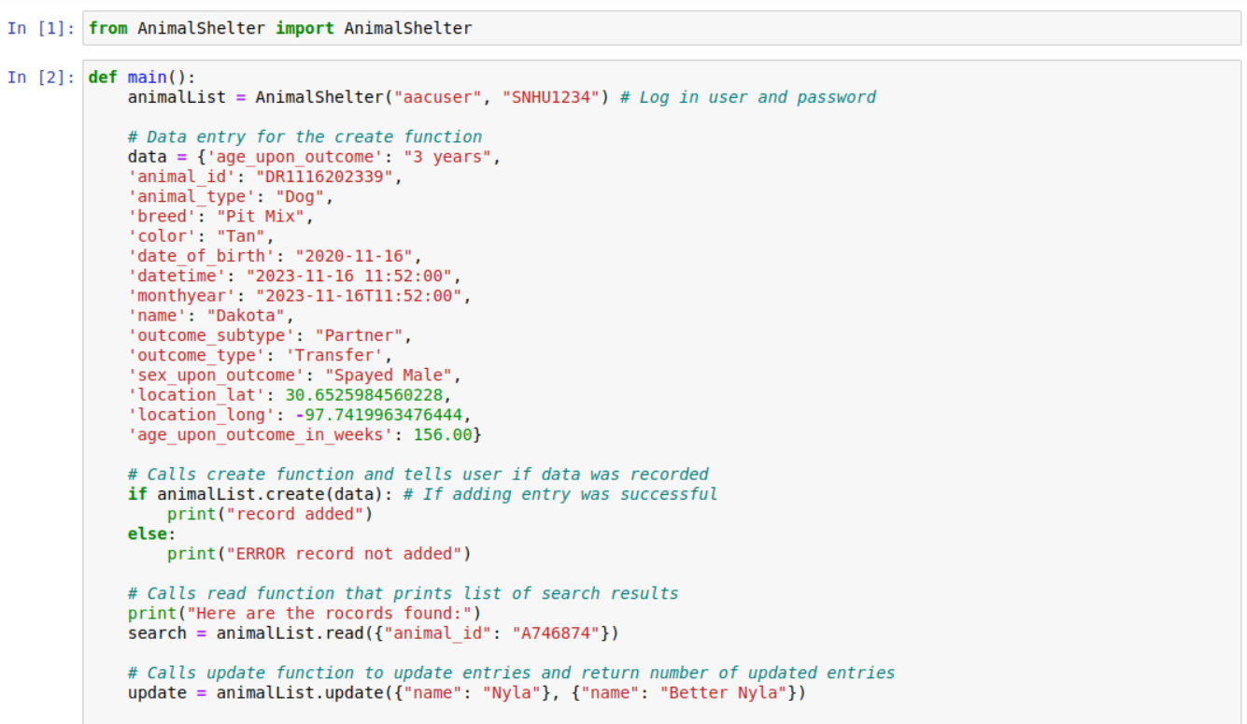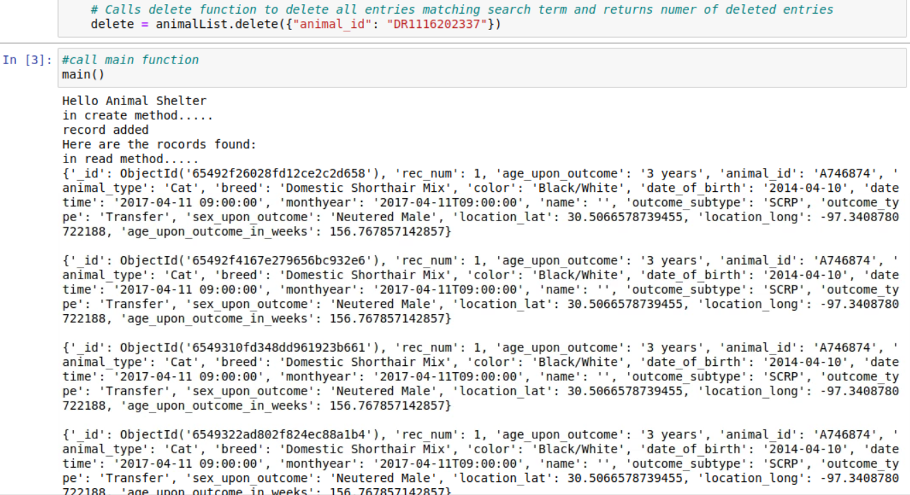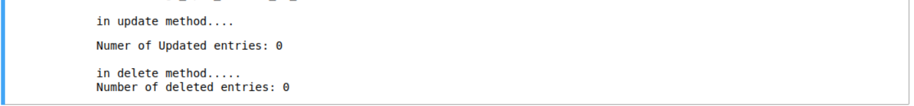

### Screenshots

Starting State of Dashboard

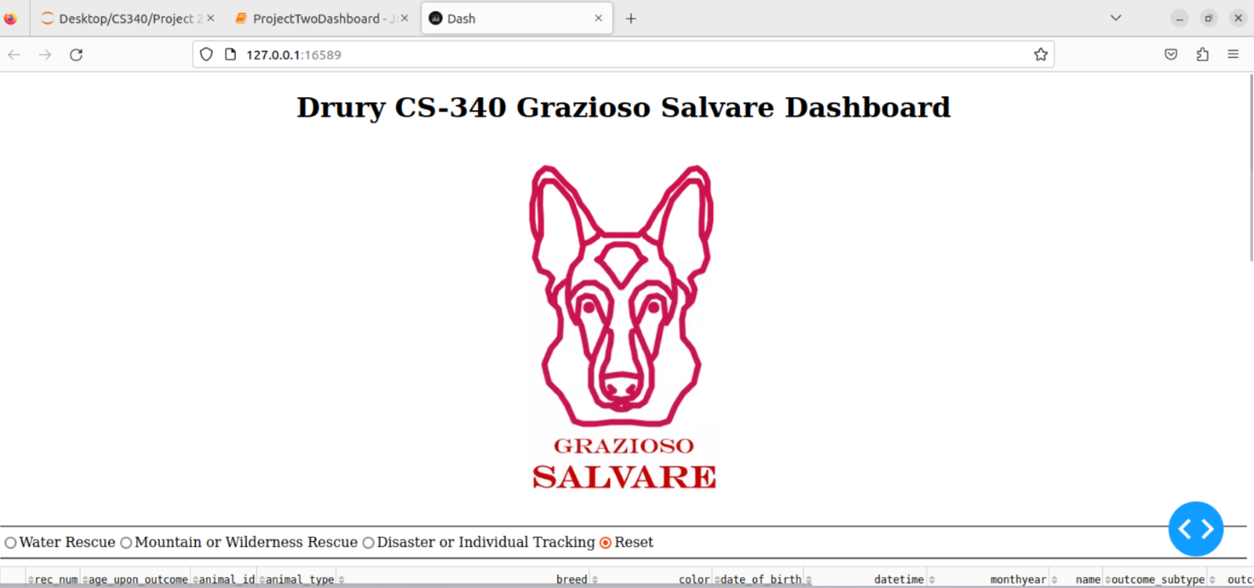

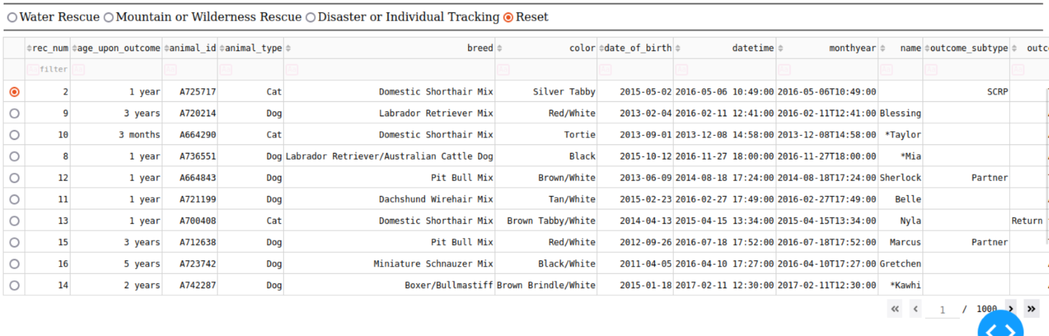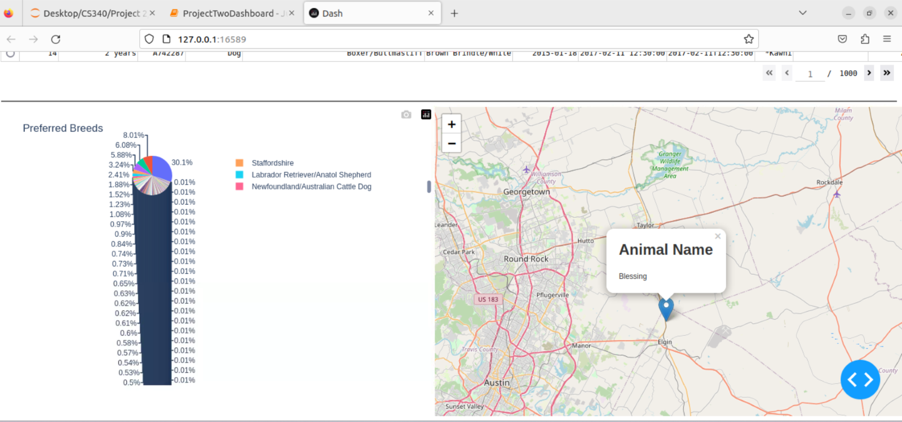

Execution After Water Rescue

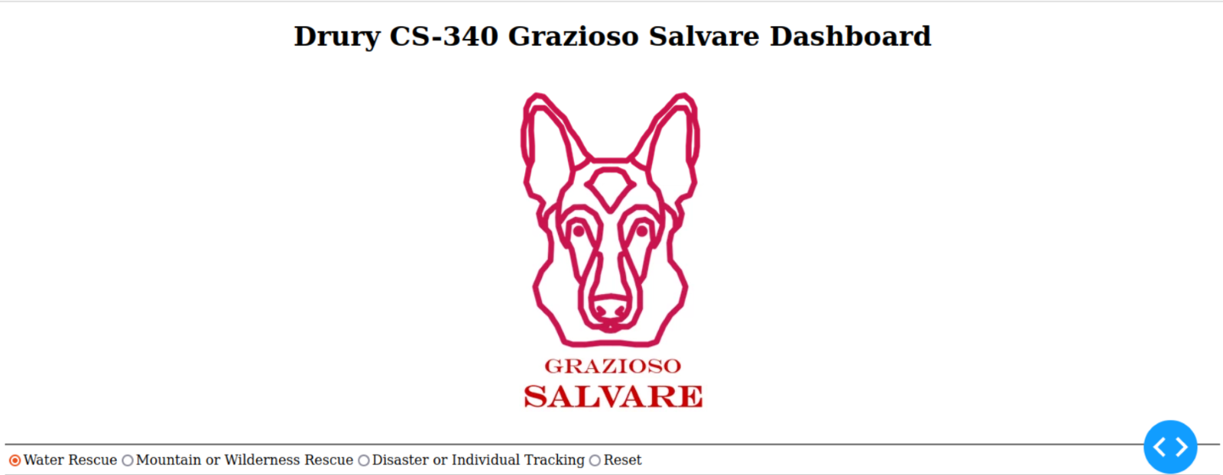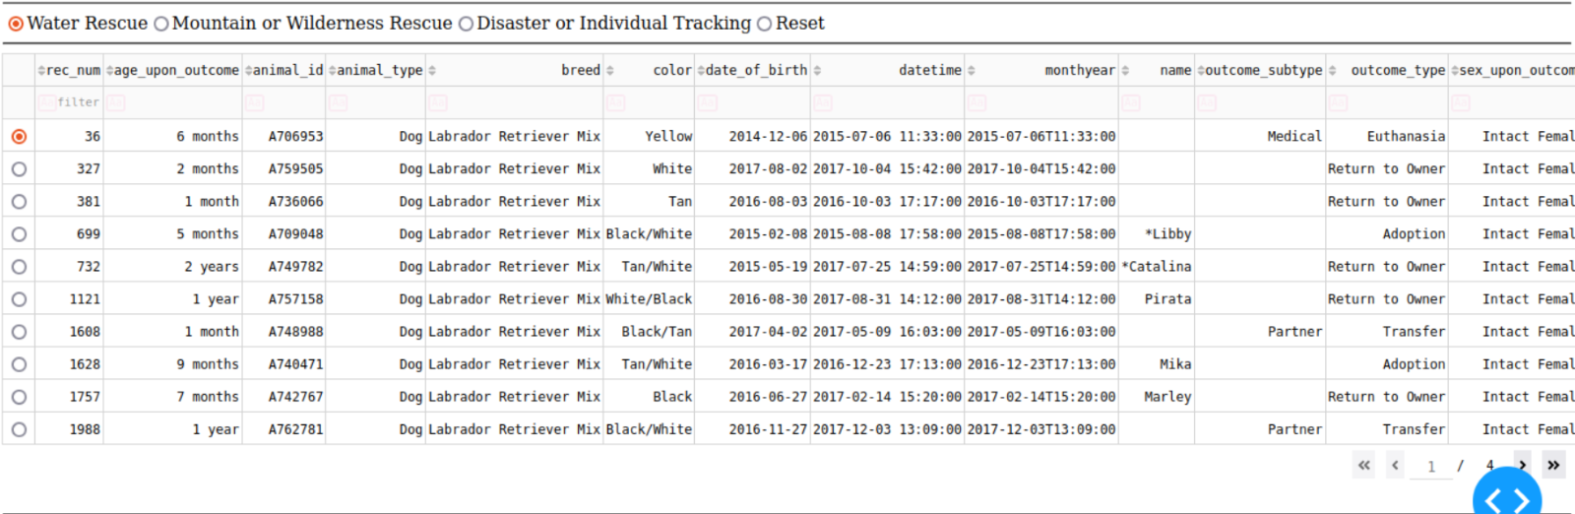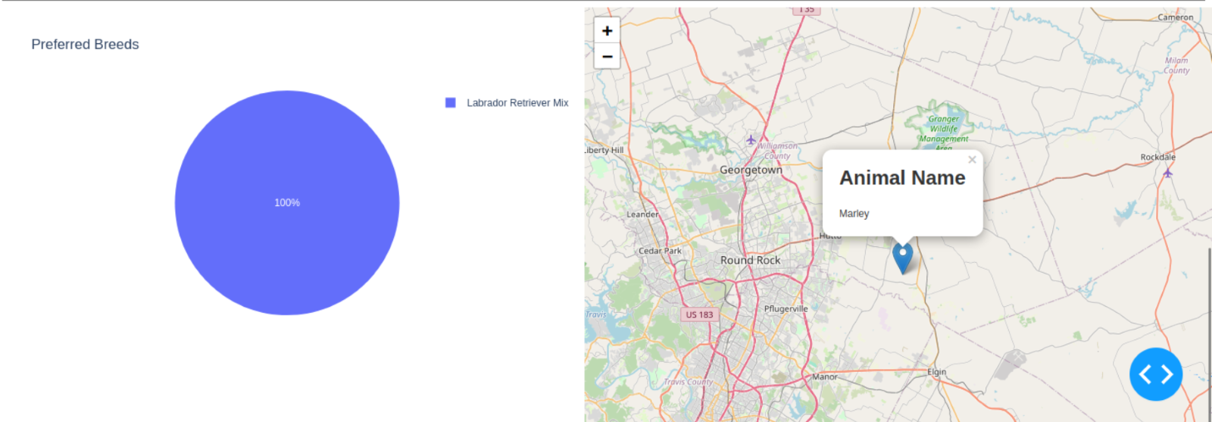

Execution After Mountain or Wilderness Rescue

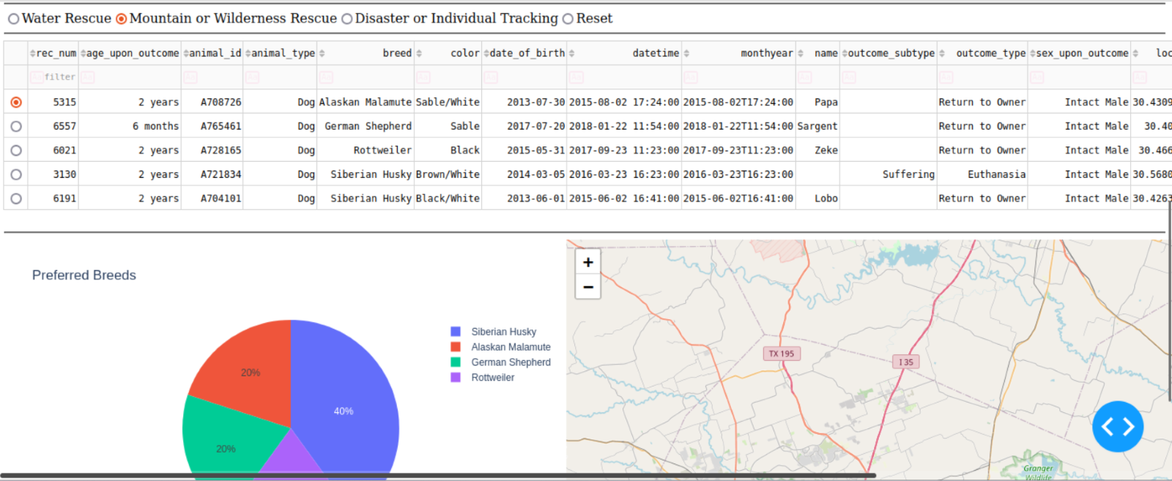

Execution After Disaster or Individual Tracking

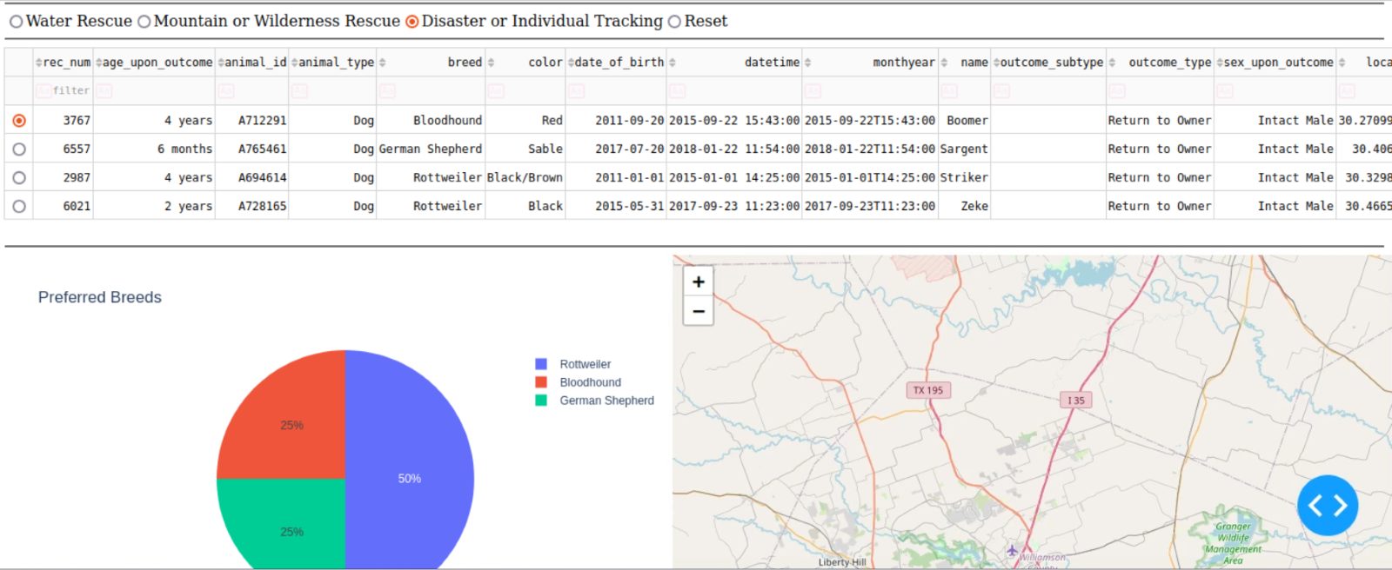

## Roadmap/Features (Optional)

*Provide an open issues list of proposed features (and known issues). If you have ideas for releases in the future, it is a good idea to list them in* *the README. What makes your project stand out?*  
  
*Note: This section is optional for the purposes of this assignment. If you choose not to fill out this section, remove it from your final README file.*

## Contact

Name: Dominic Drury

Email: dominic.drury@snhu.edu